Main tabs

1. Introduction

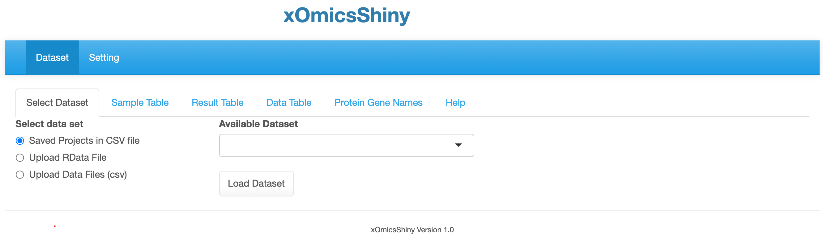

Sub tabs for different functionalities.

Main tabs

* 1. 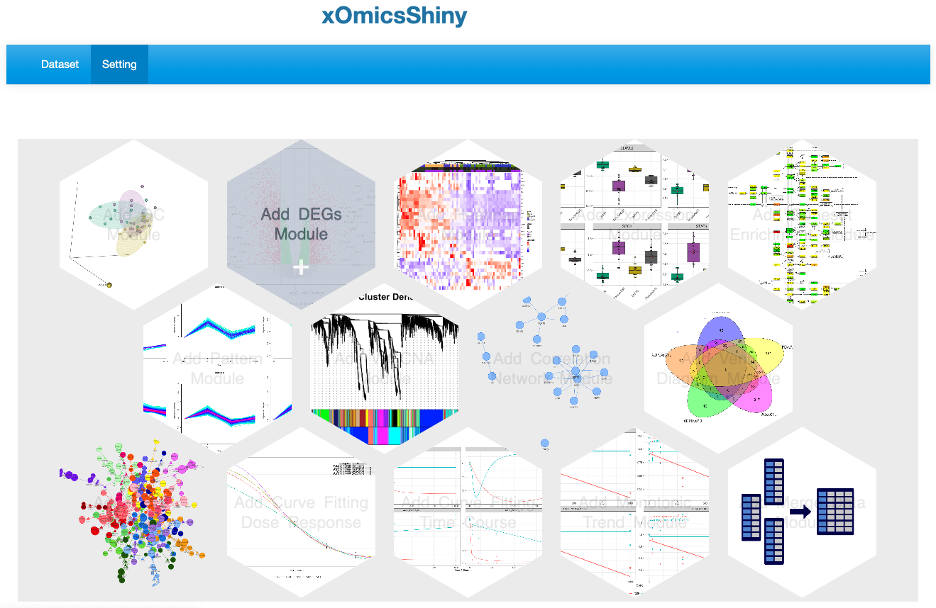
  2. 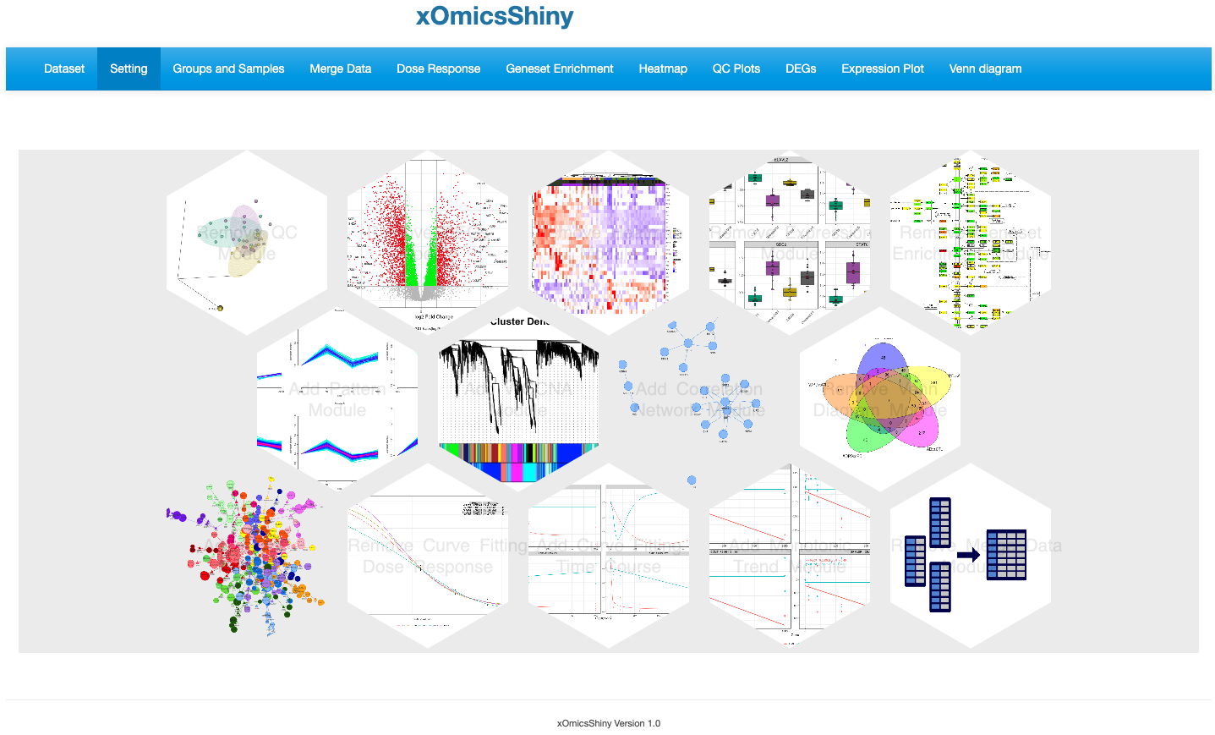

1. Installation
2. Dataset Module
   1. 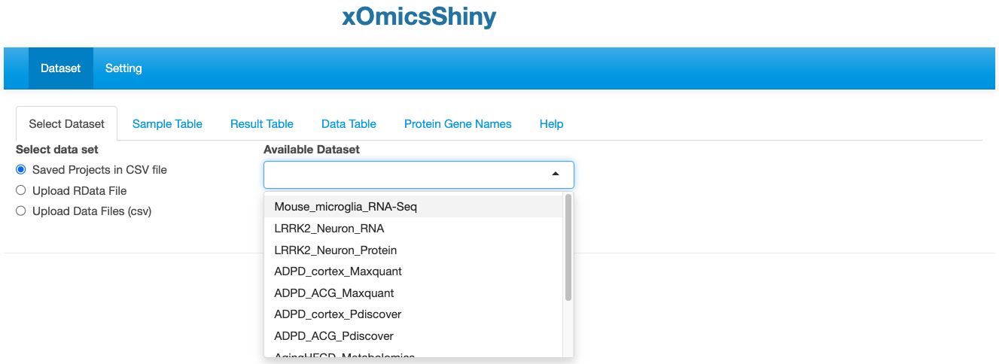
   2. 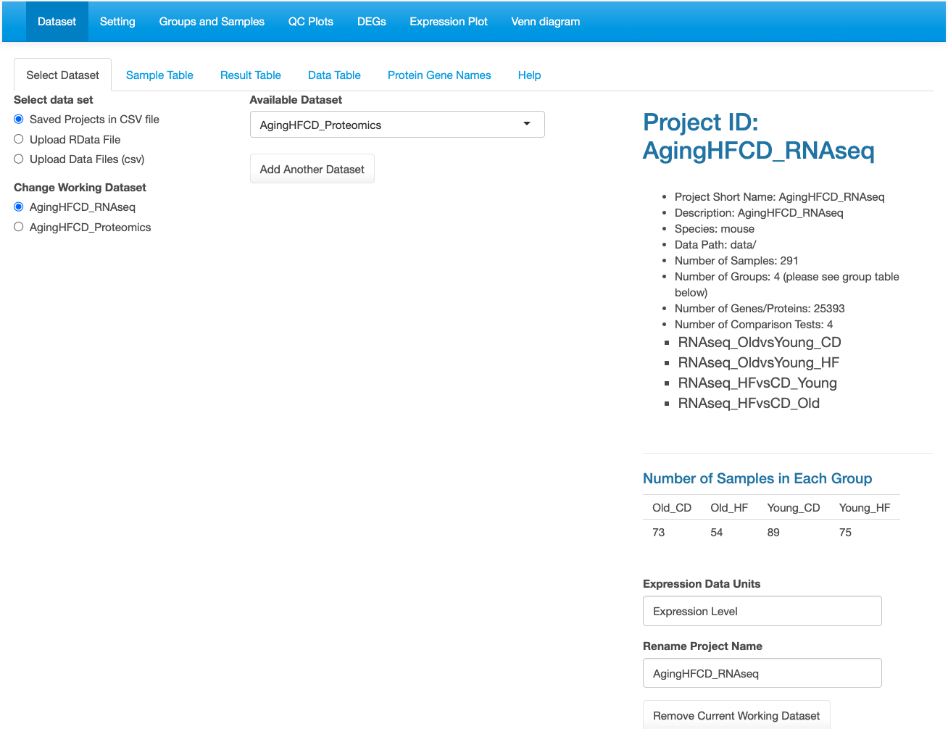

Click to remove current dataset.

Details about the dataset and listing the comparisons as defined during data upload.

Loaded datasets are listed here.

Multiple datasets can be loaded.

* 1. 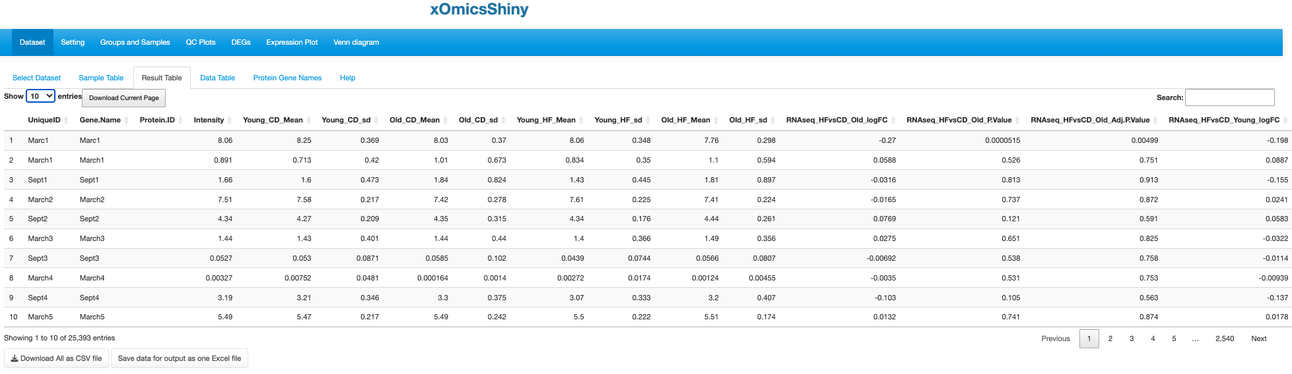

Mean and SD per group.

logFC, P value and adjusted P value for each comparison and SD per group.

* 1. 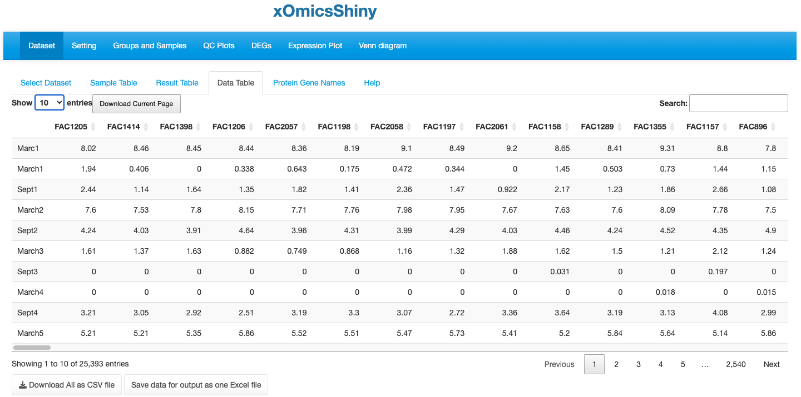

Each column is one sample.

Each row is one gene.

* 1. 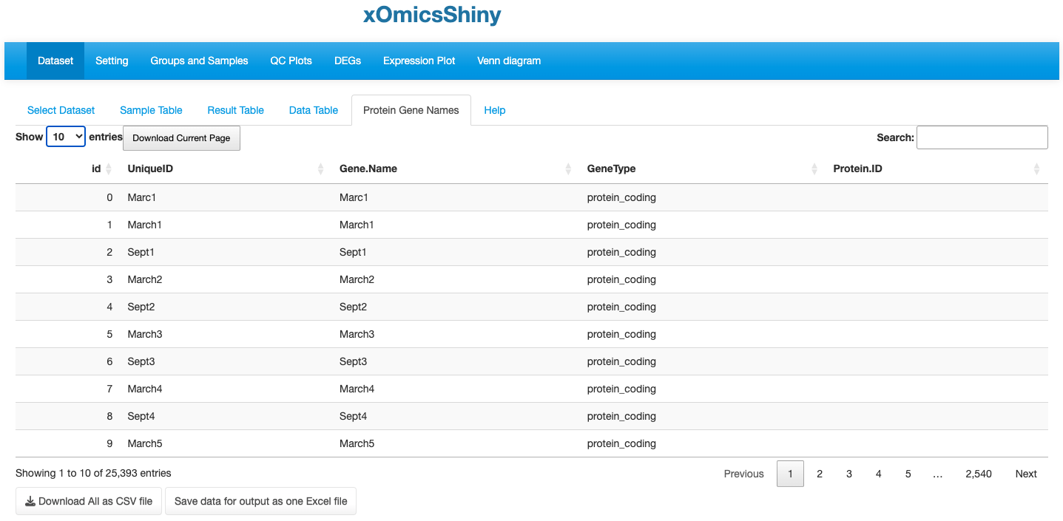

For proteomic data, Protein.ID can be matched to Gene.Name.

For metabolomic data, it only lists all the KEGG compound IDs.

* 1. 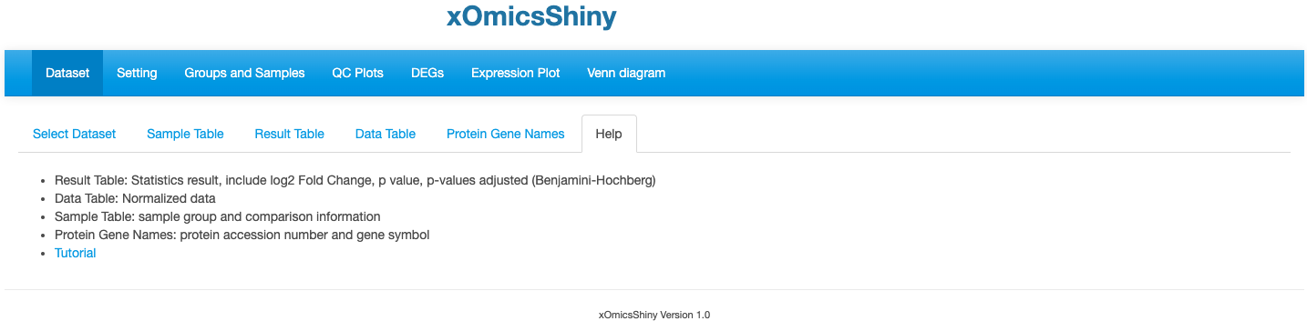

1. Groups And Samples
   1. 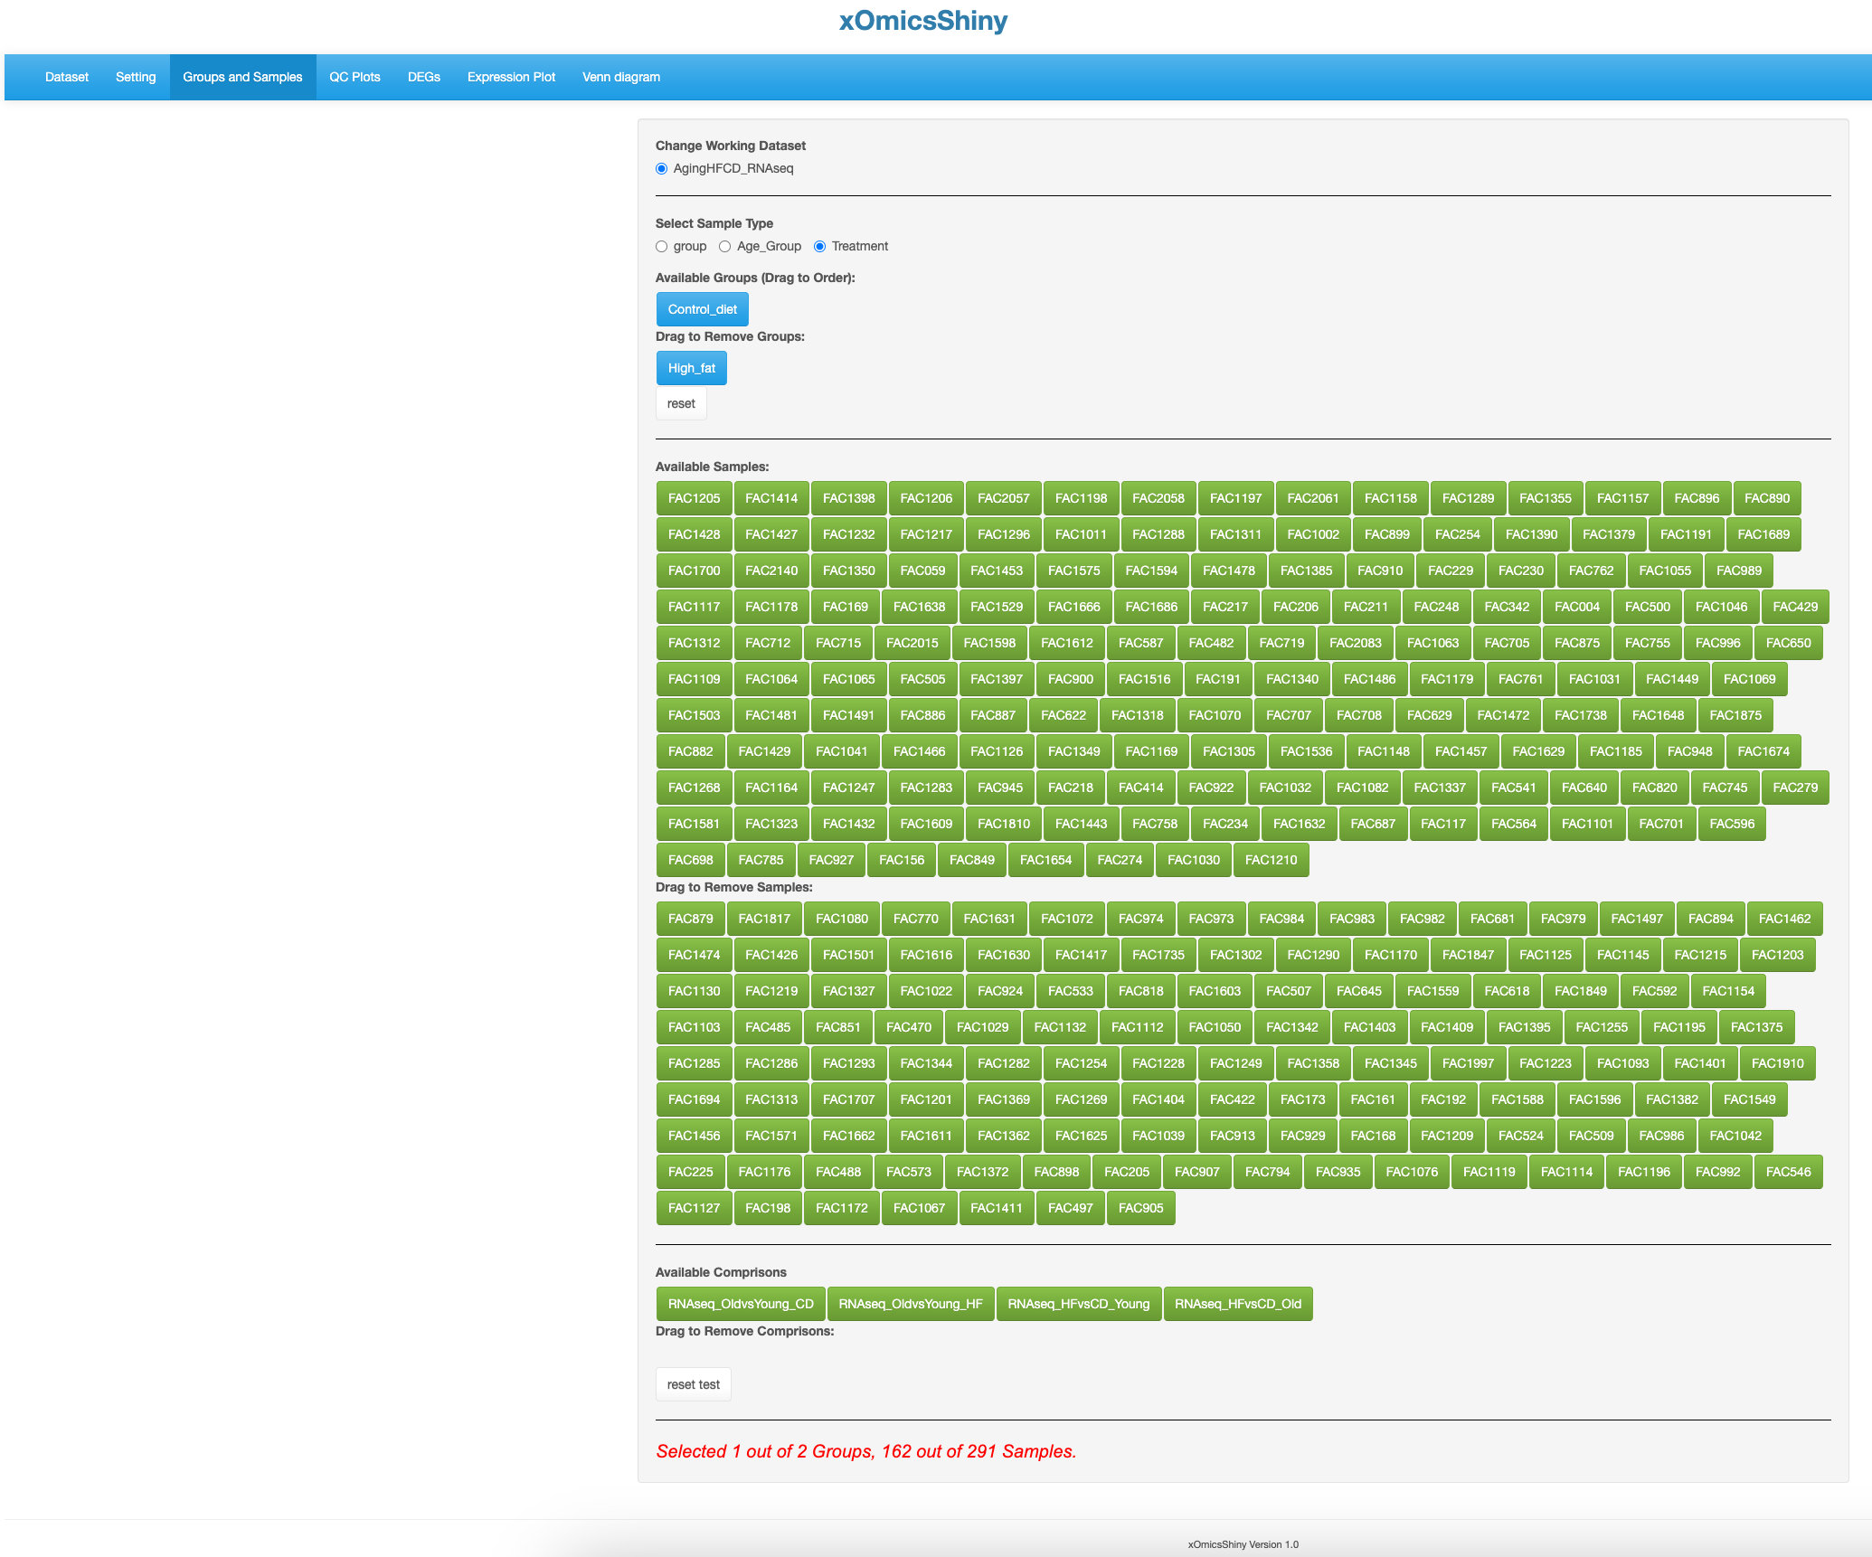

Include or exclude samples based on comparisons.

Include or exclude samples based on sample name.

Include or exclude samples based on meta data.

1. QC Plots Module
   1. 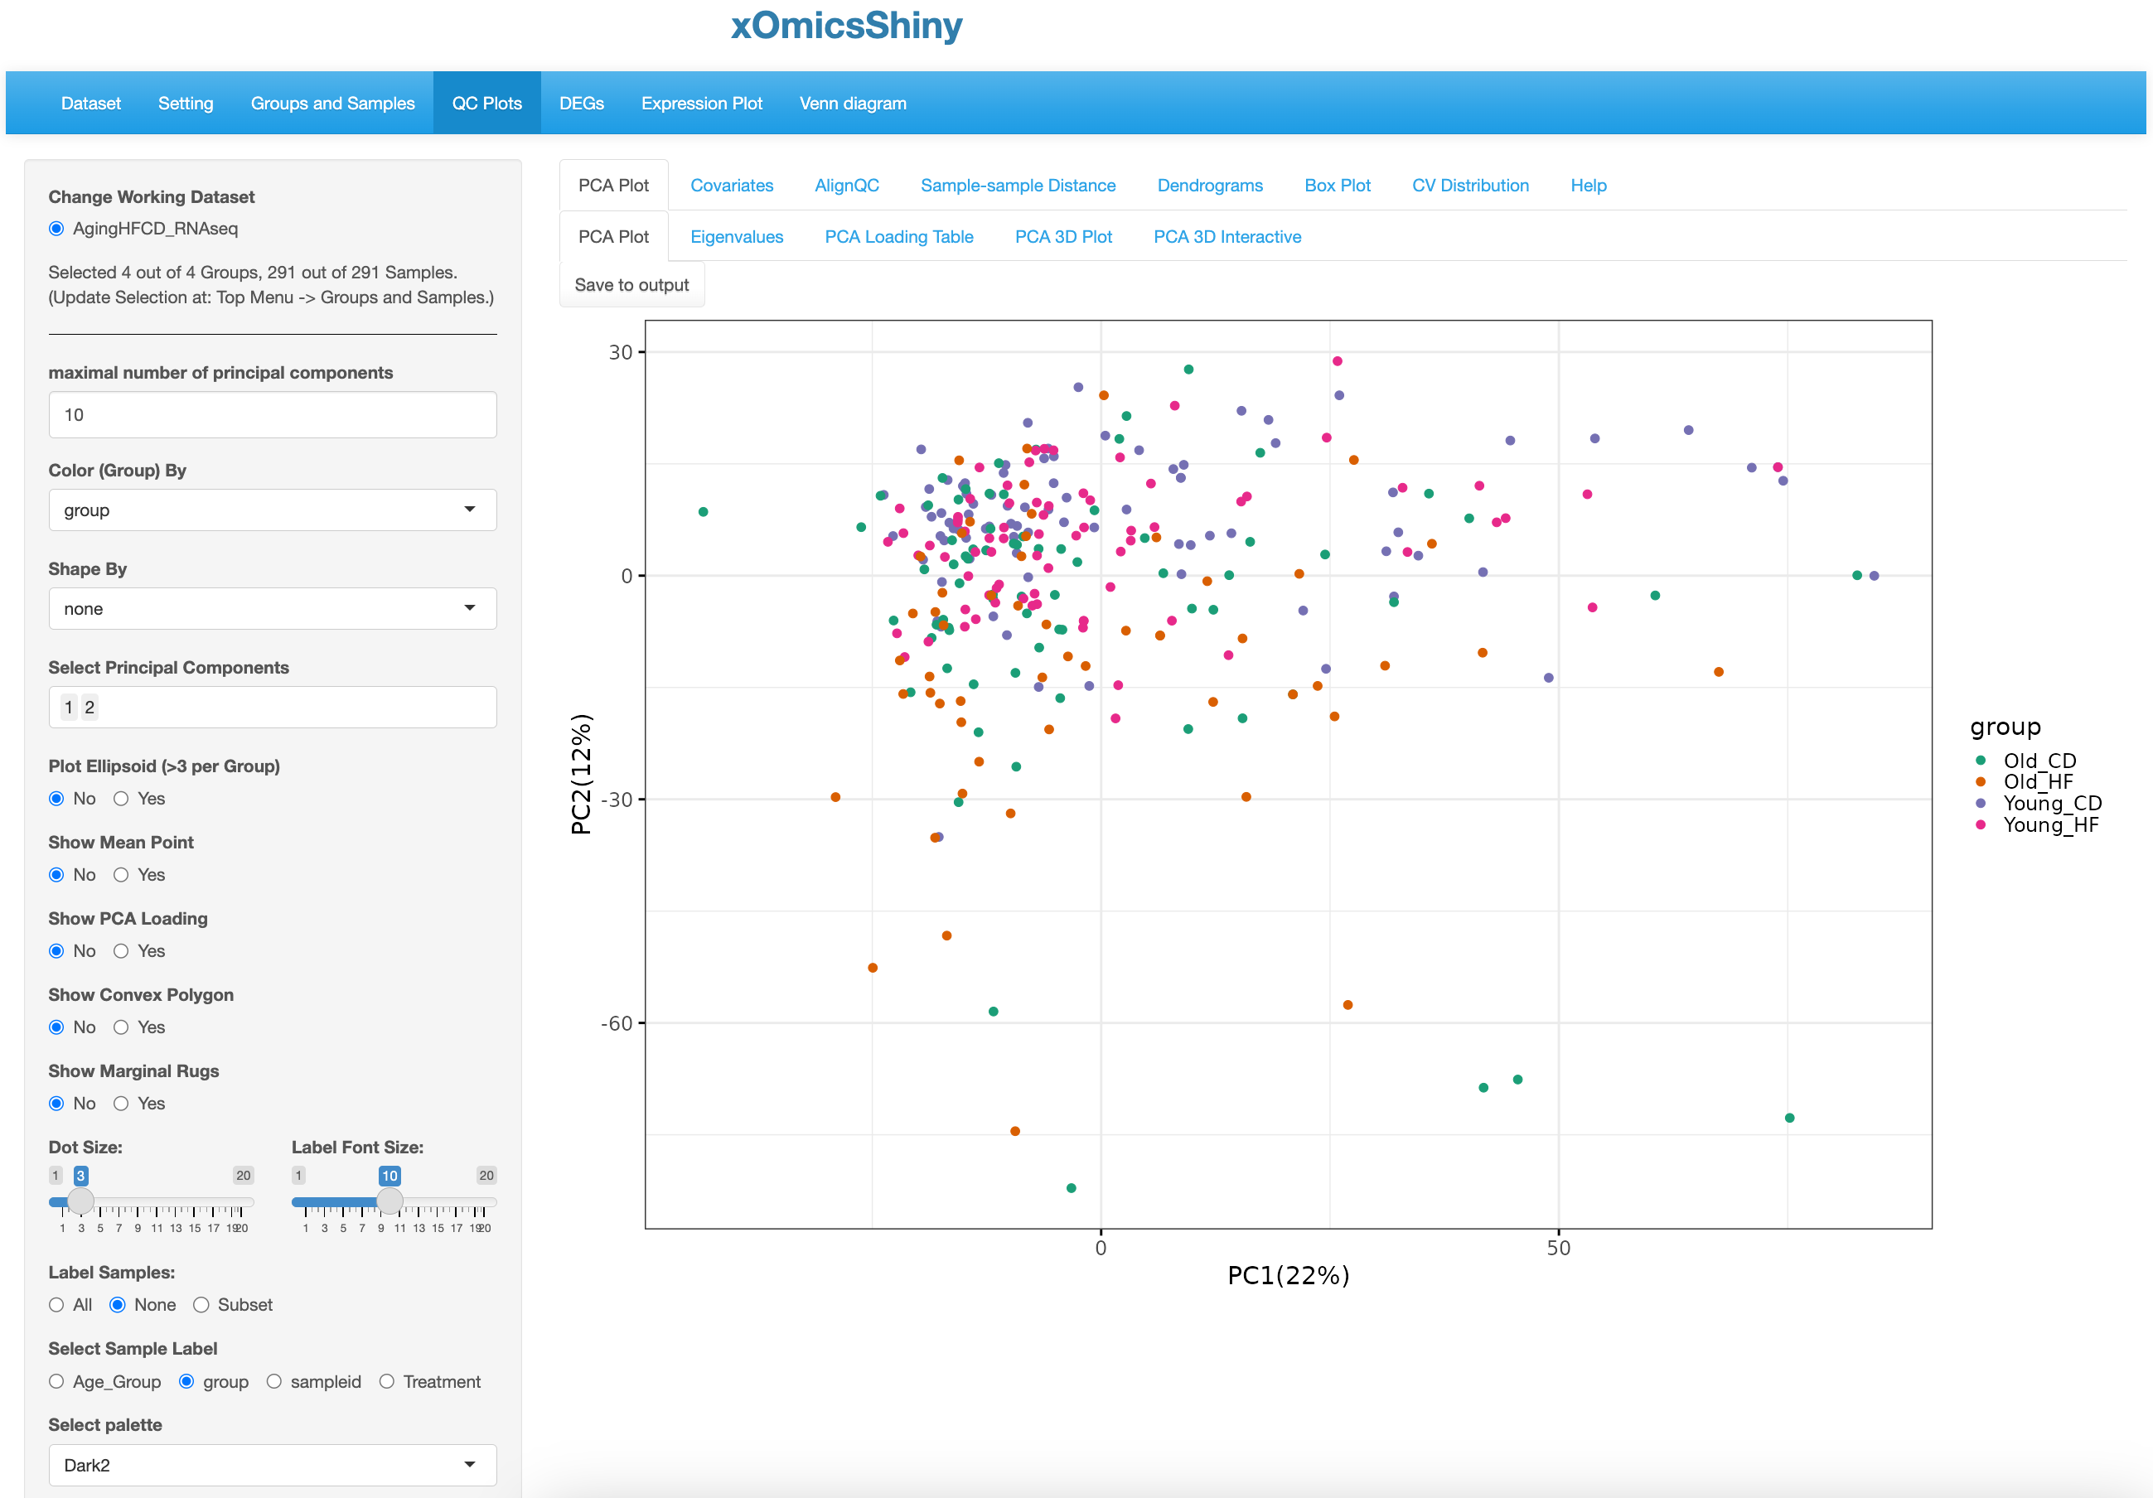

Customizable panel

Label for color.

* 1. 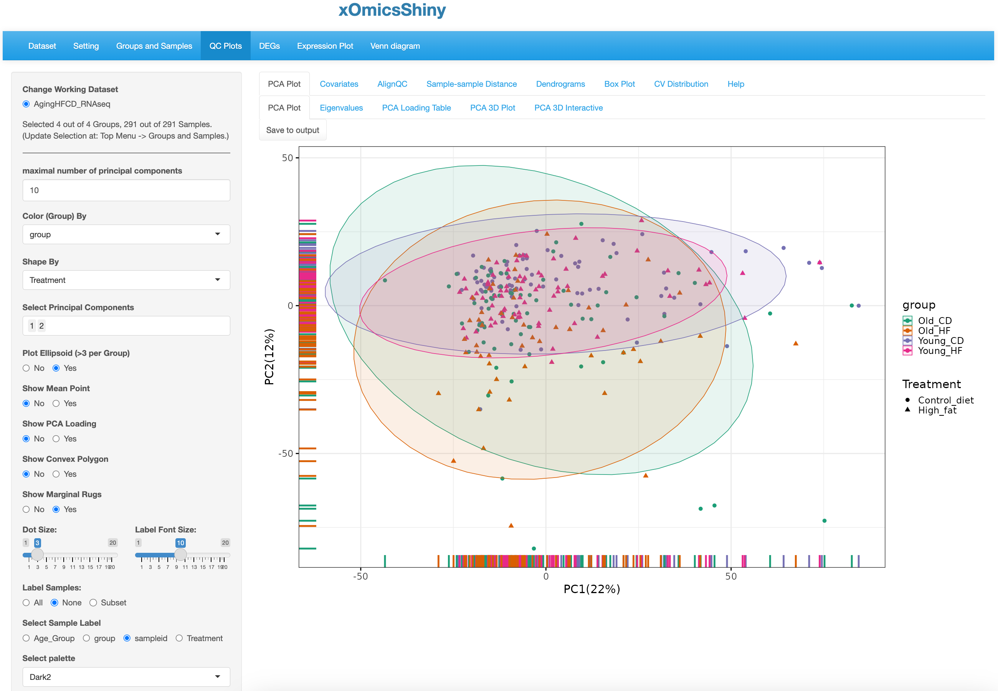

Show sample distribution along the axis

Show separation of all groups by Ellipsoid

Shape by Treatment

Click to save

* 1. 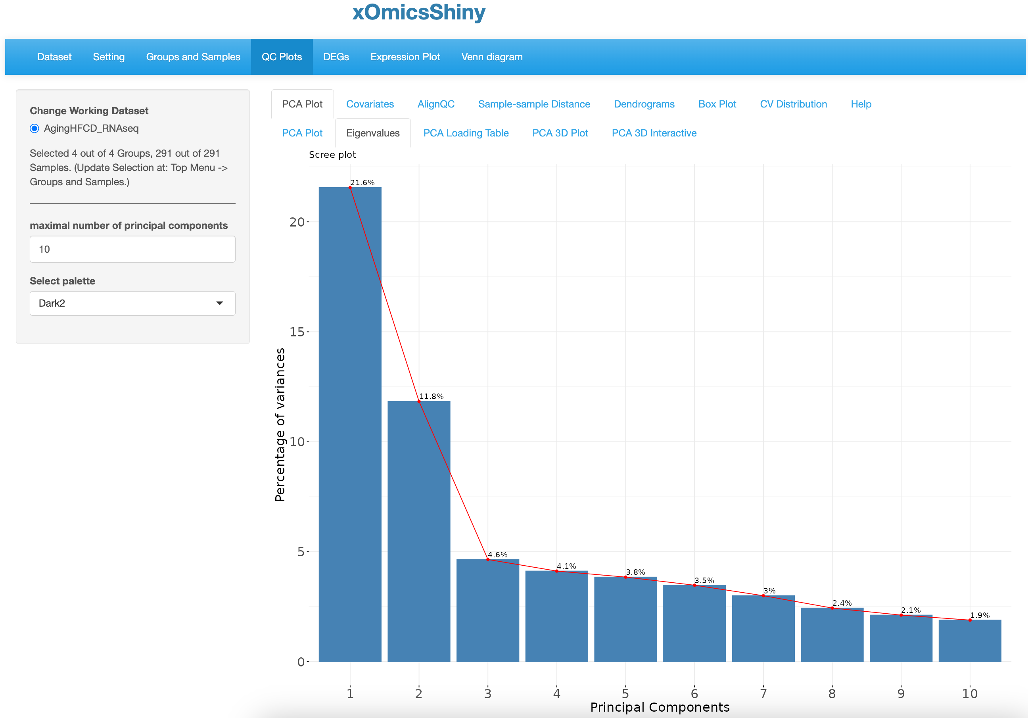
  2. 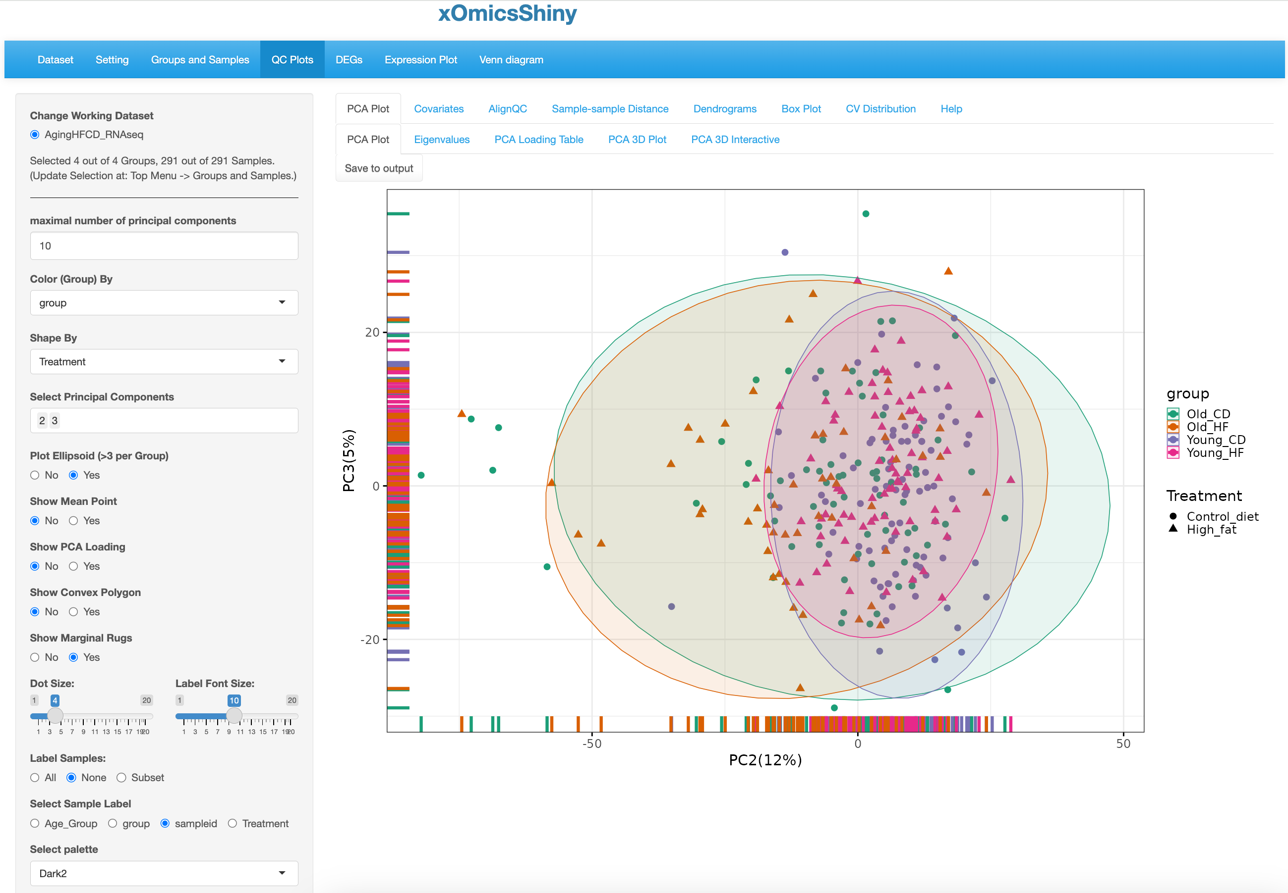
  3. 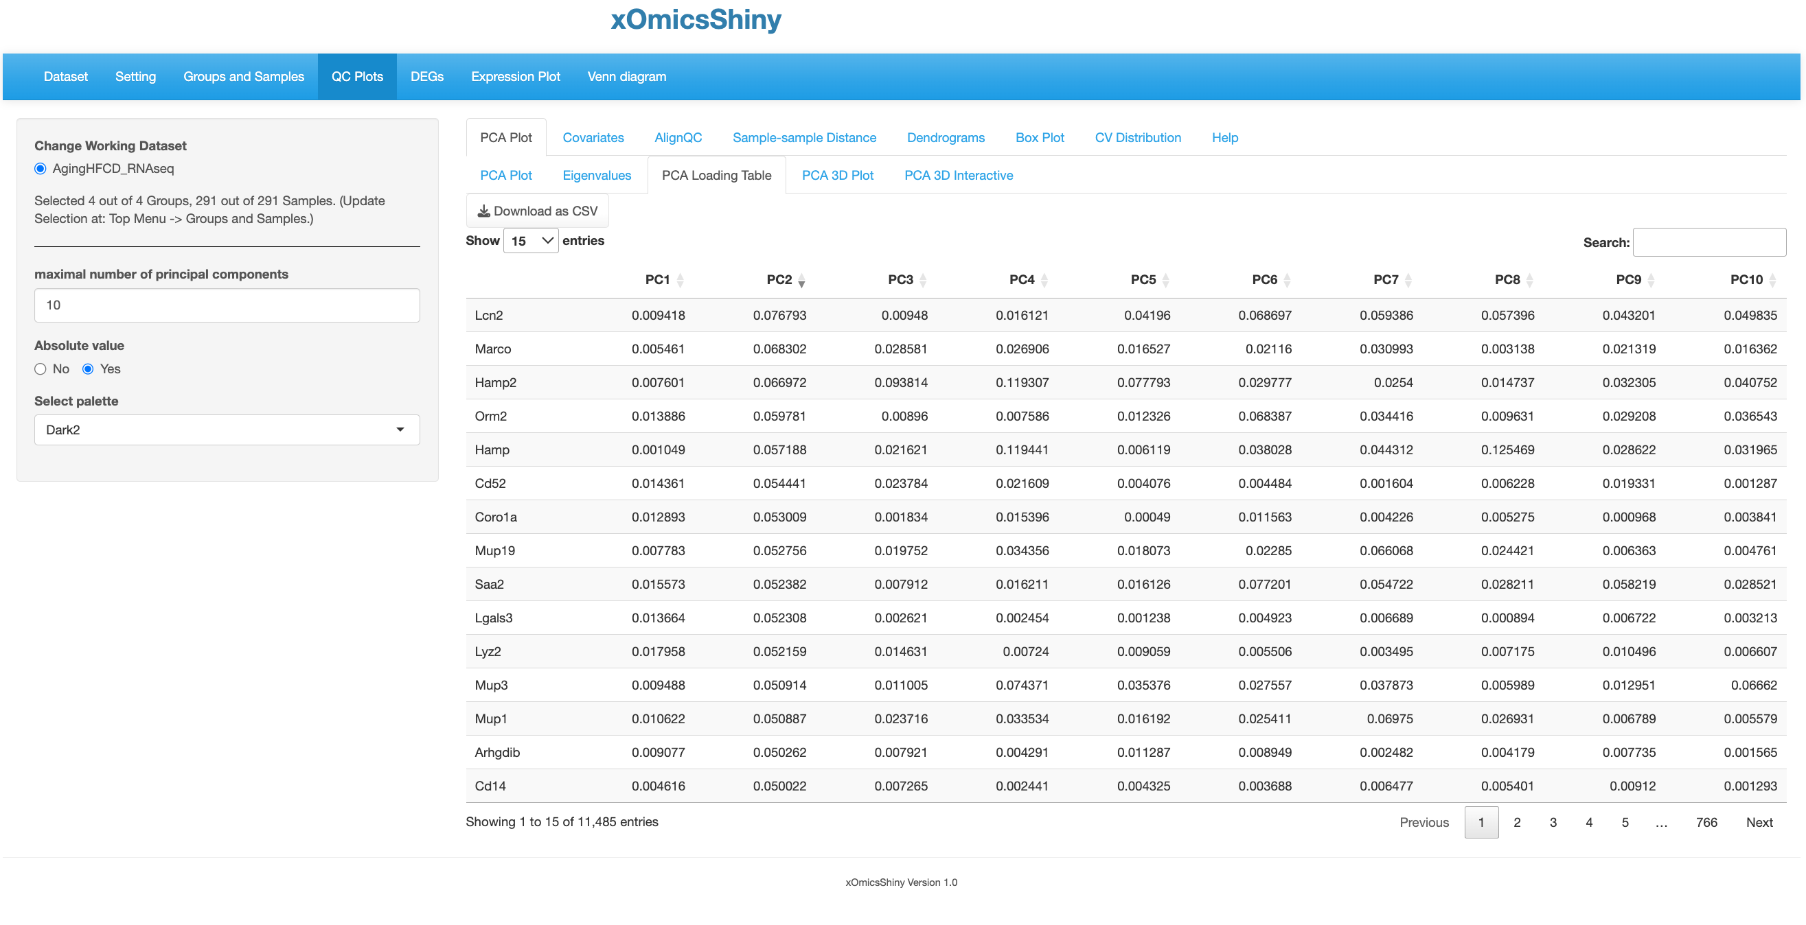

Sort by PC2

Use absolute value so that you can see the genes of both directions together by sorting a PC column.

* 1. 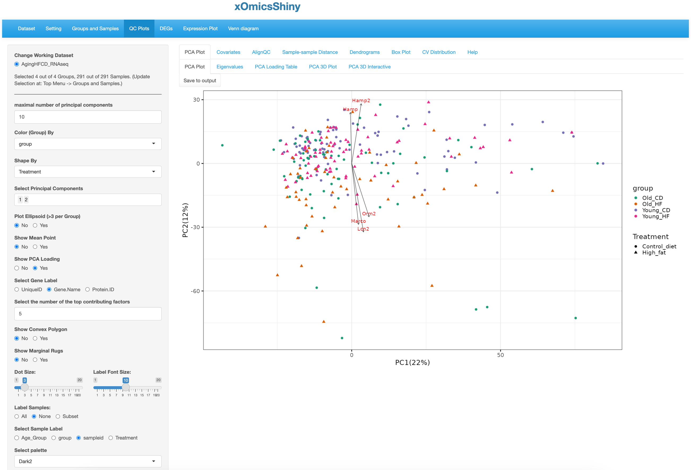

The top five contributing genes are shown using arrows pointed to their coordinates from the origin.

Select to show PCA loading, select gene label and set the number of top genes here.

* 1. 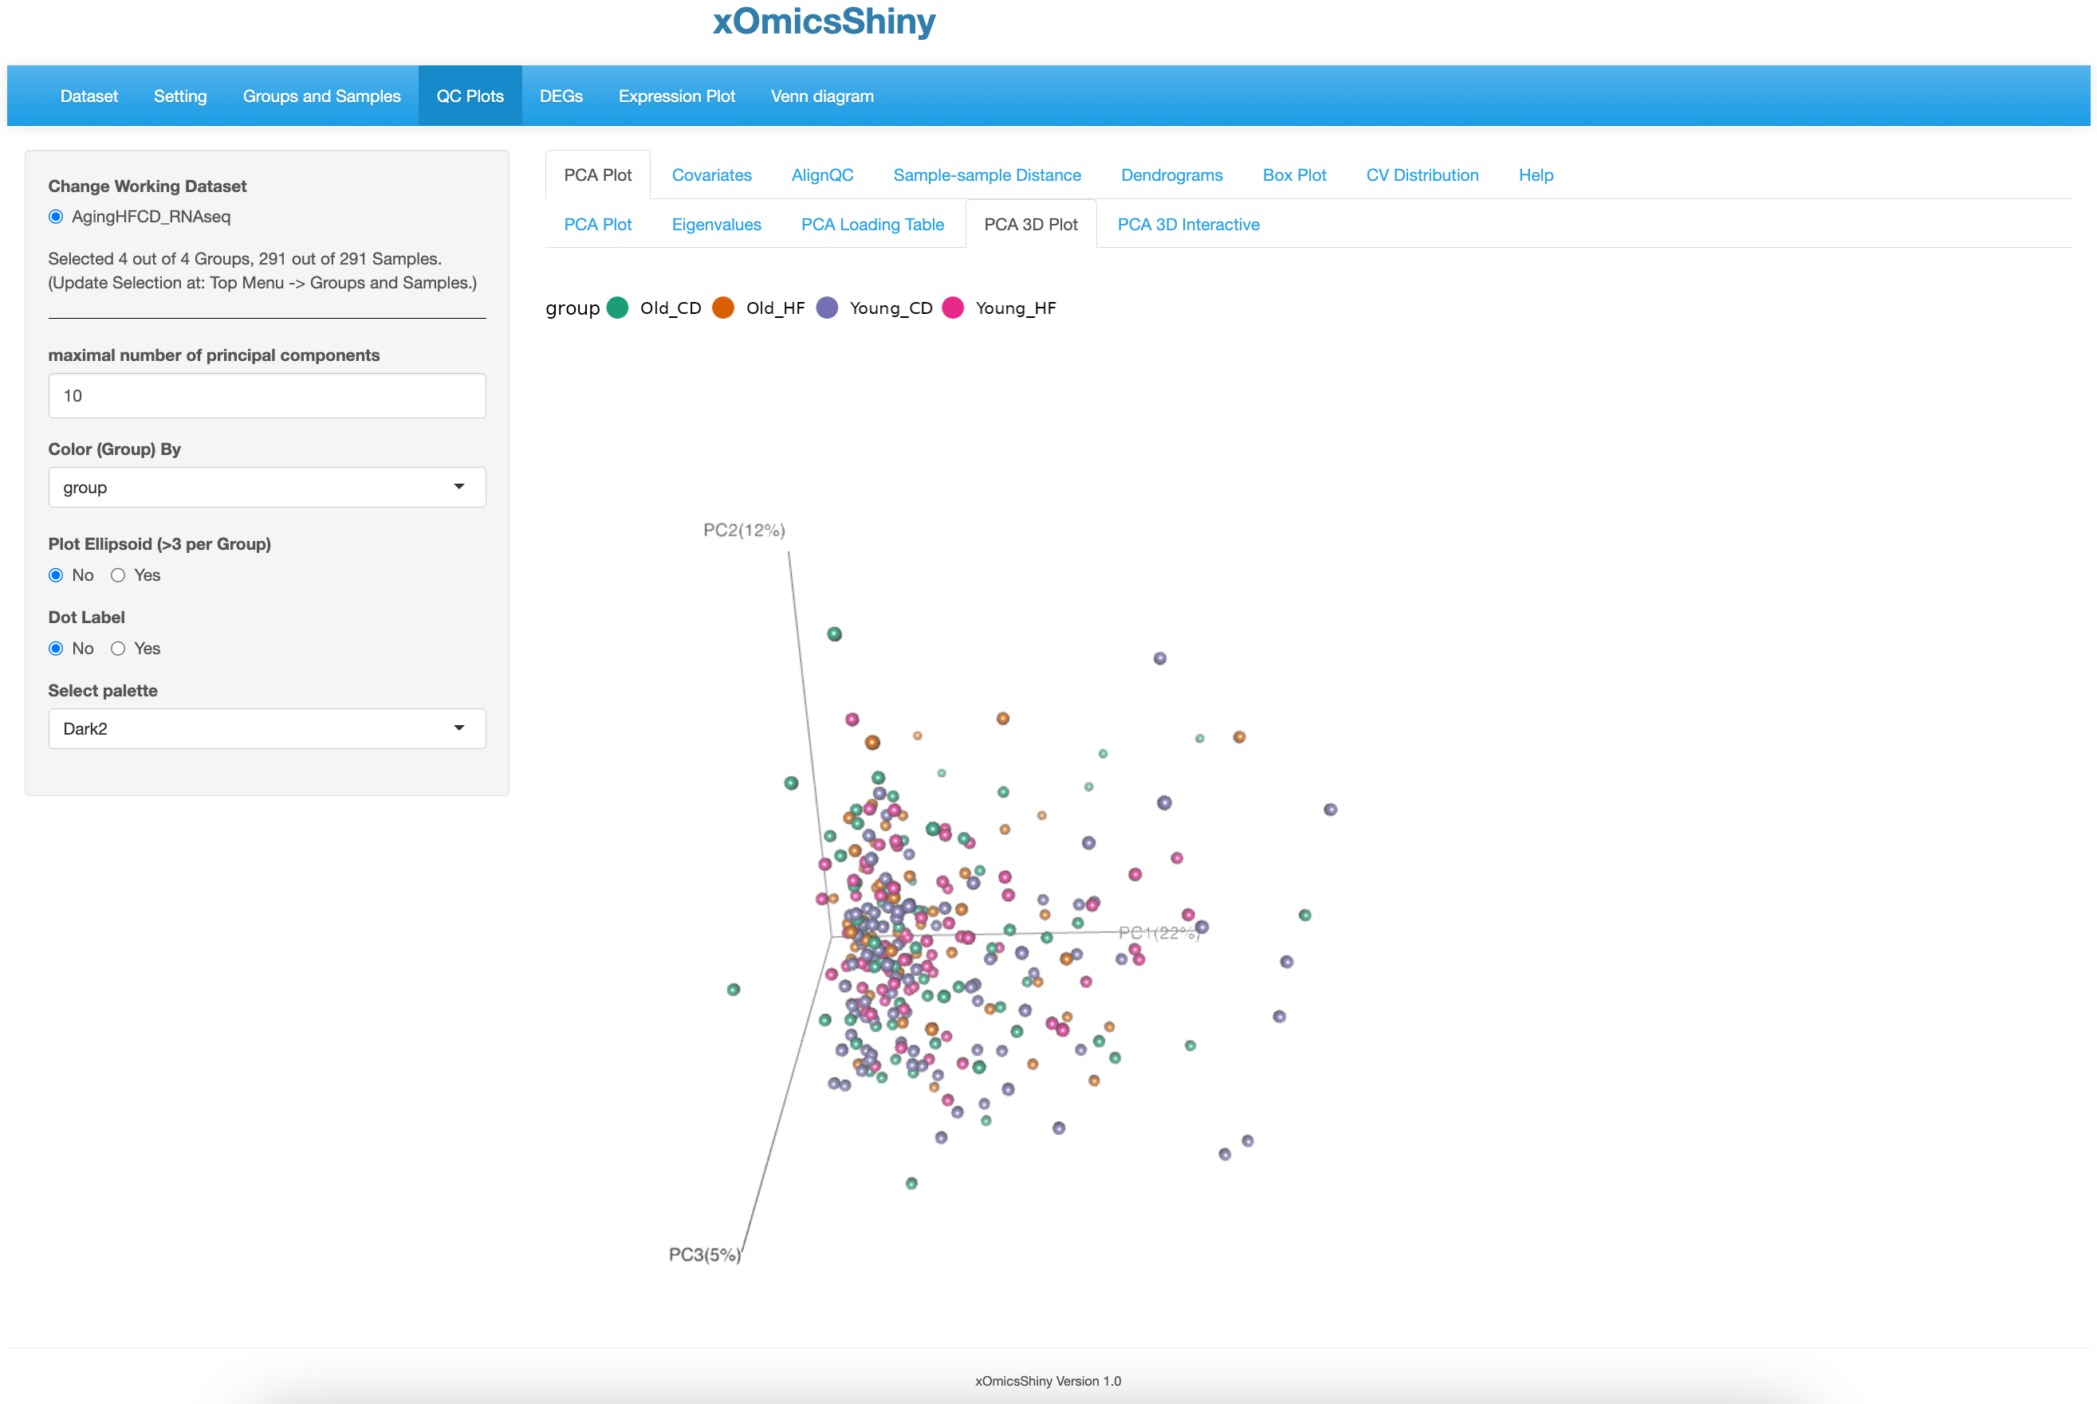

Rotate the plot to view 3D structure.

* 1. 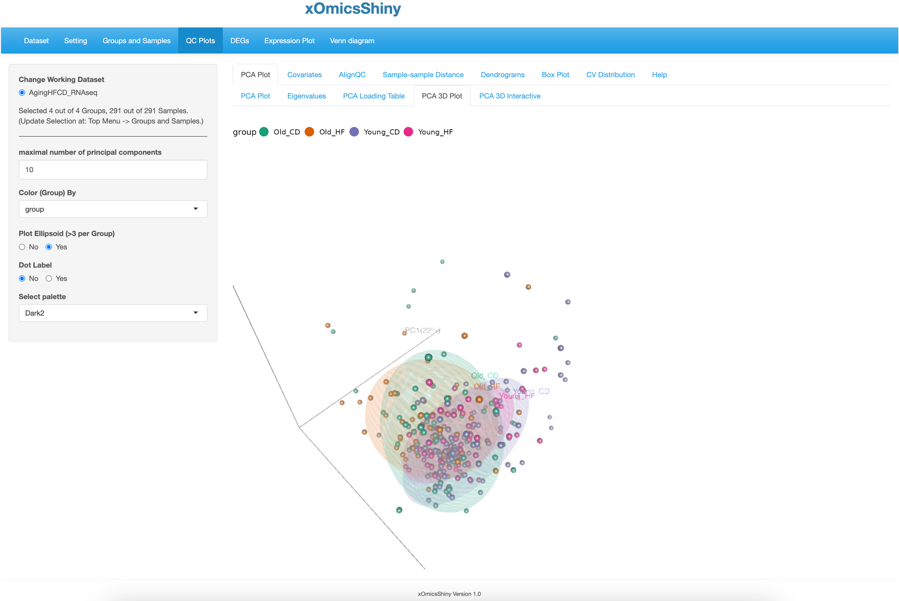

Rotate the plot to view the overlap and separation of the groups.

* 1. 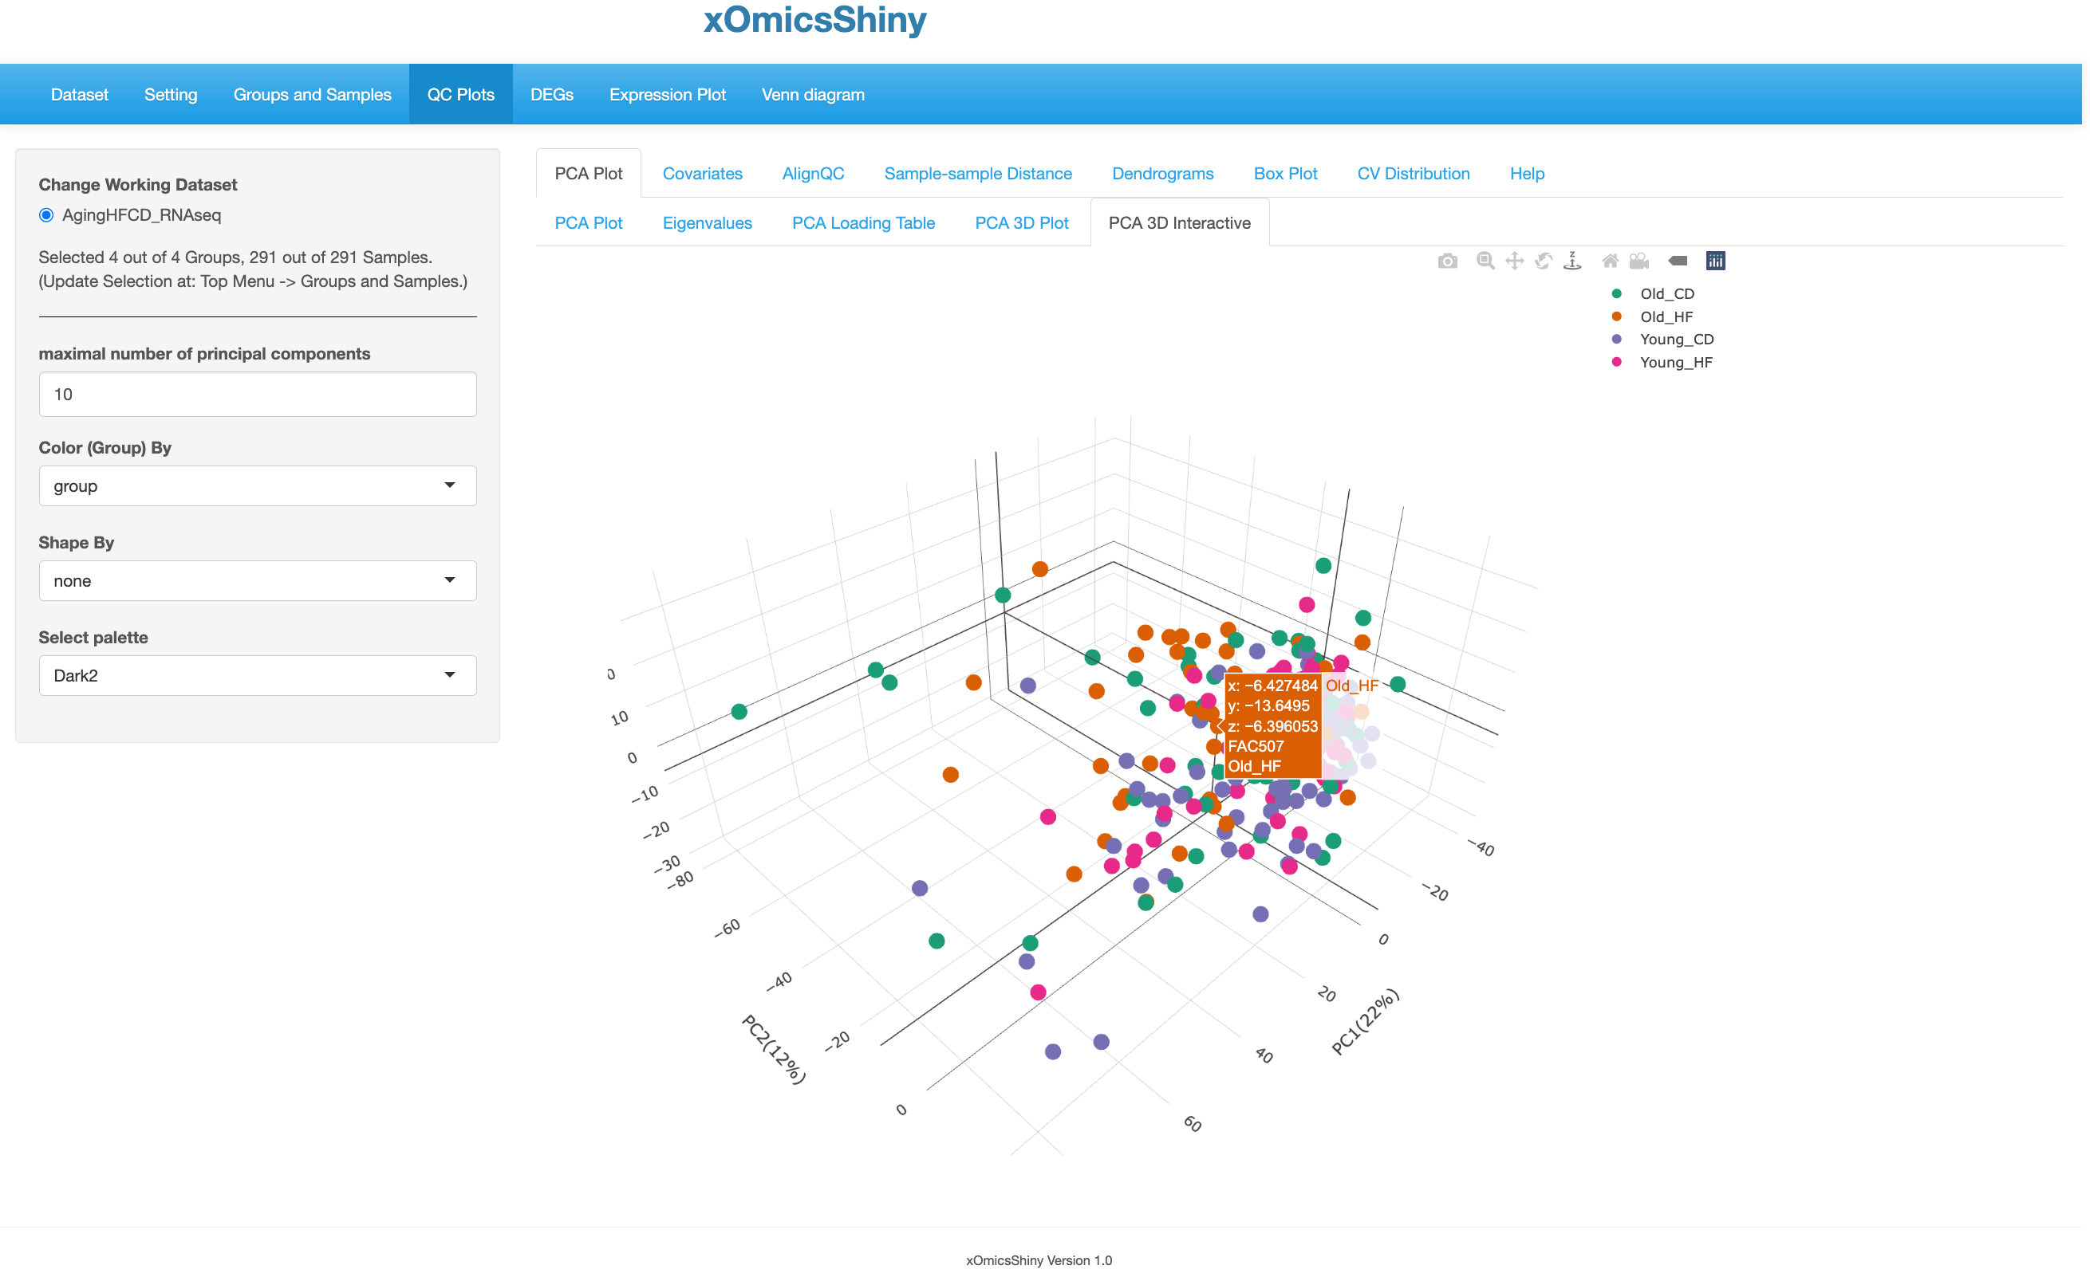

Hover over sample to get detailed information.

* 1. 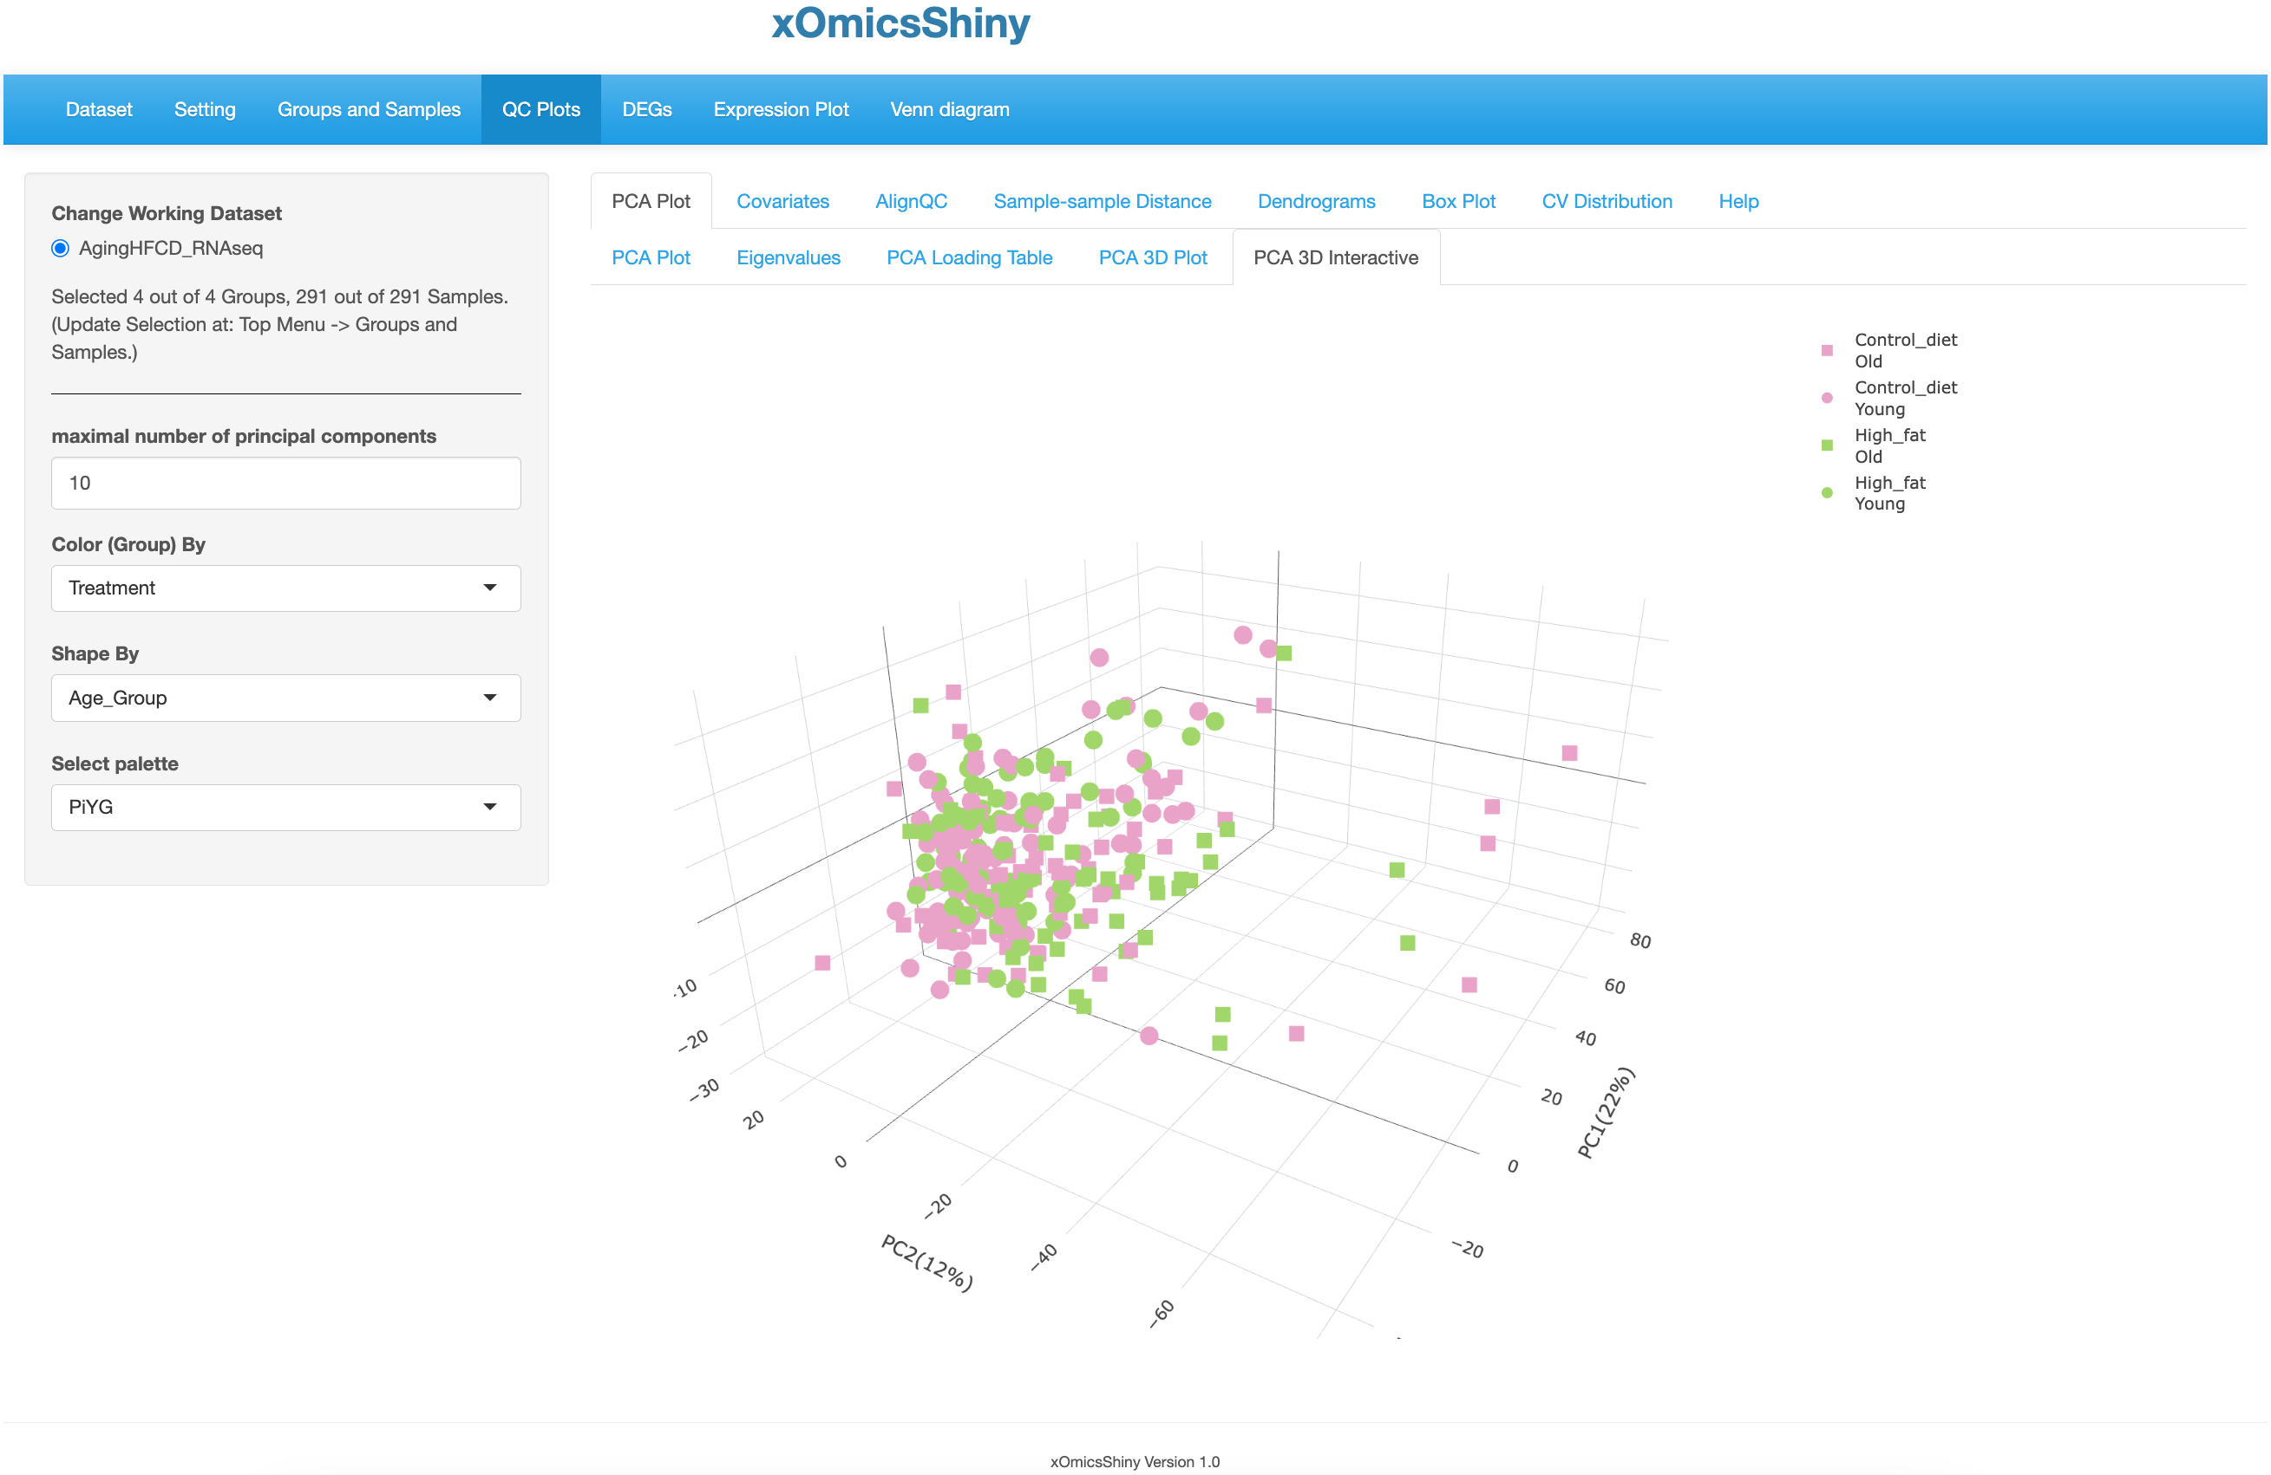
  2. 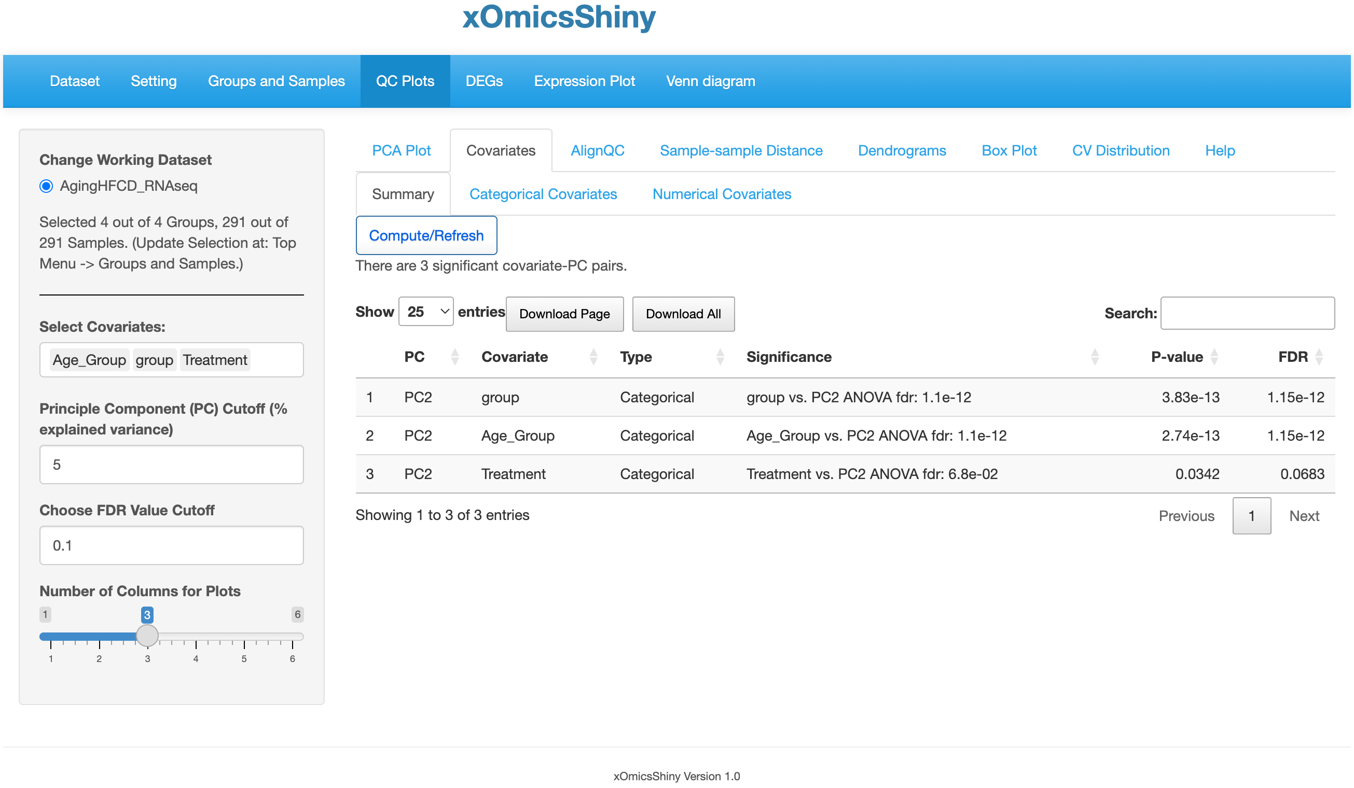

Click to compute or refresh if parameters are changed.

* 1. 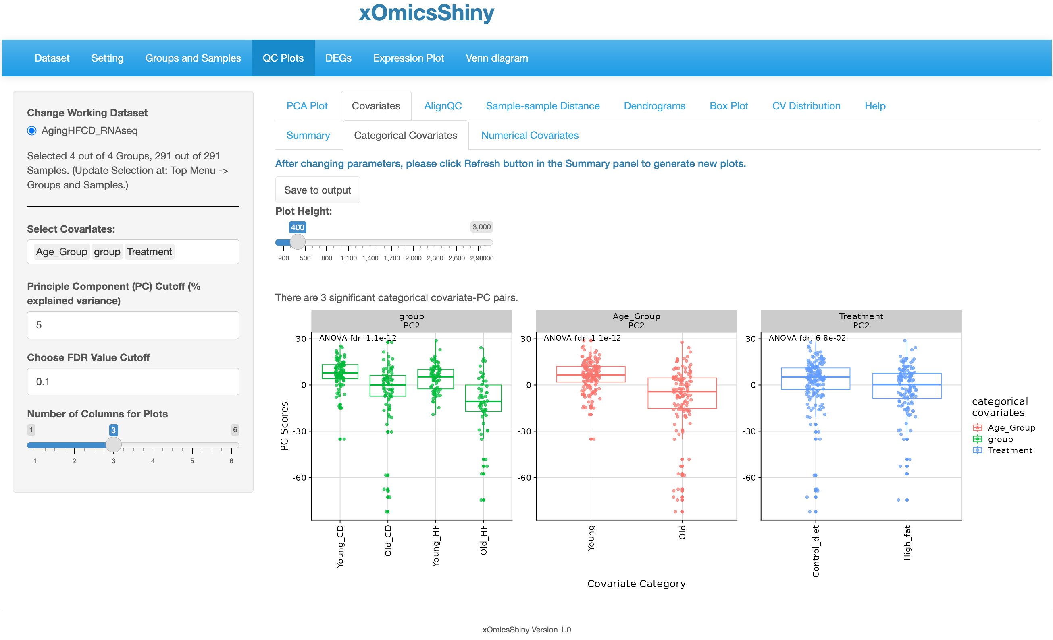
  3. 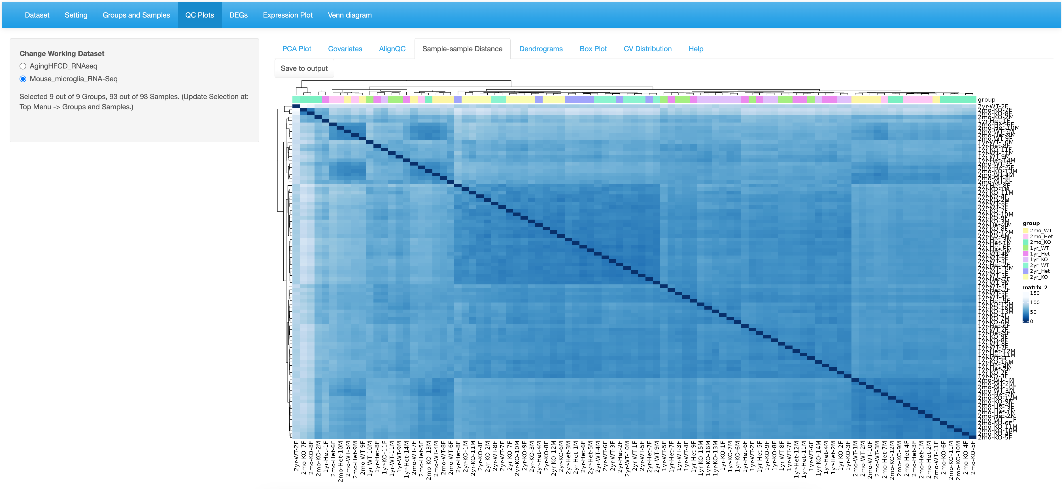
  4. 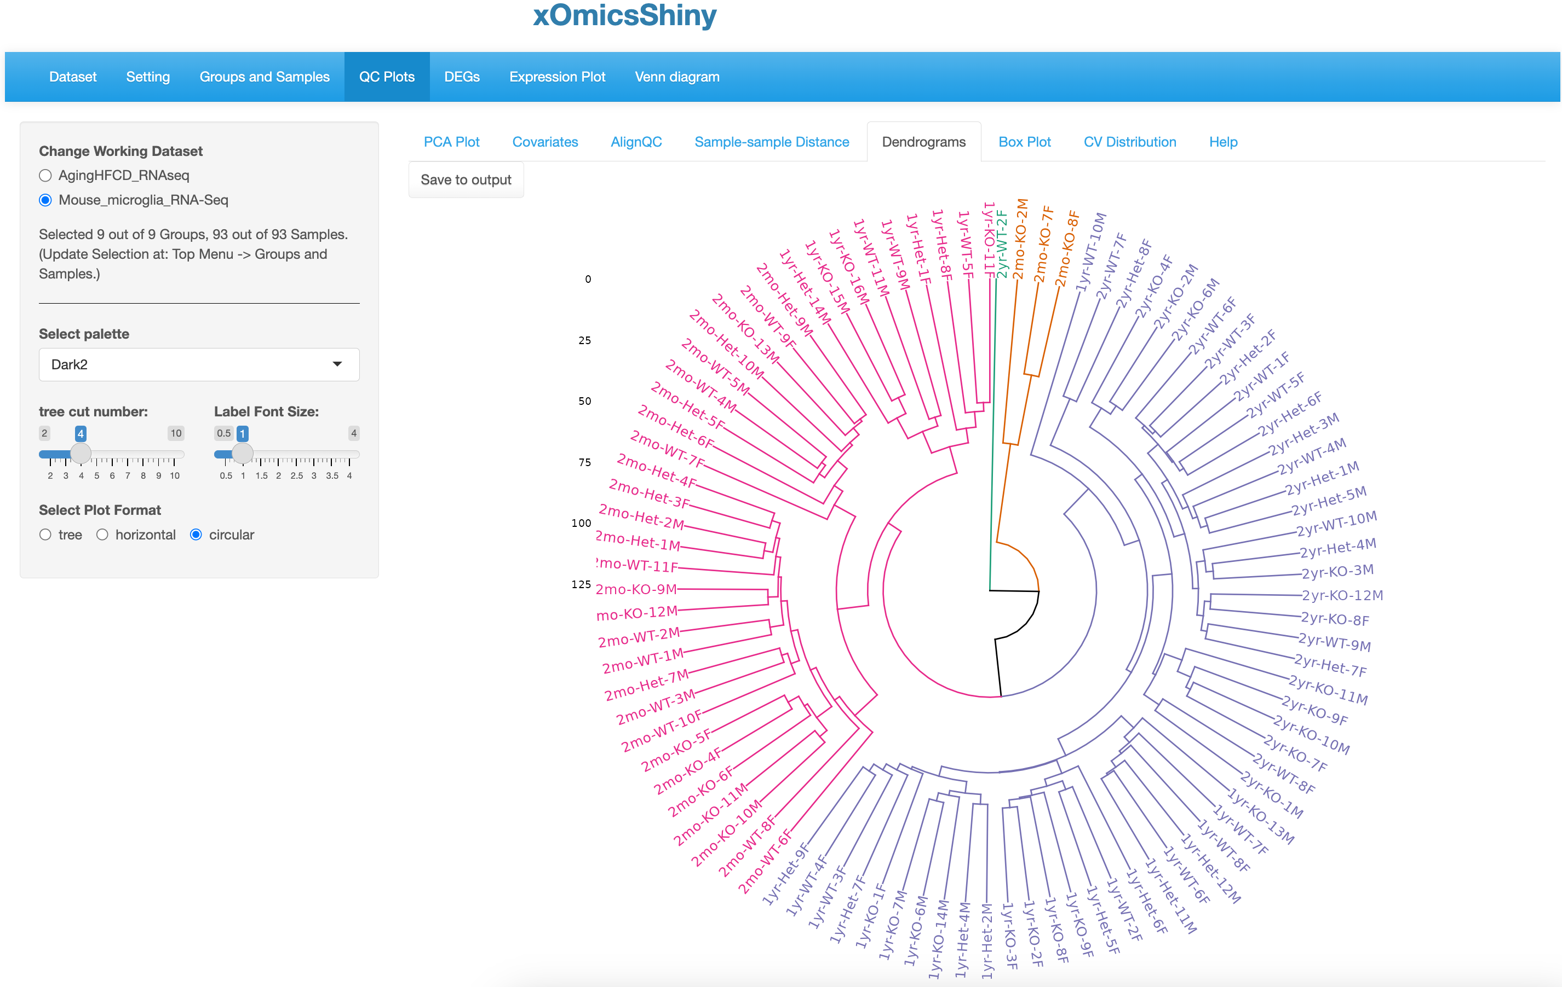

Click to save.

4 regions don’t separate the Age.

* 1. 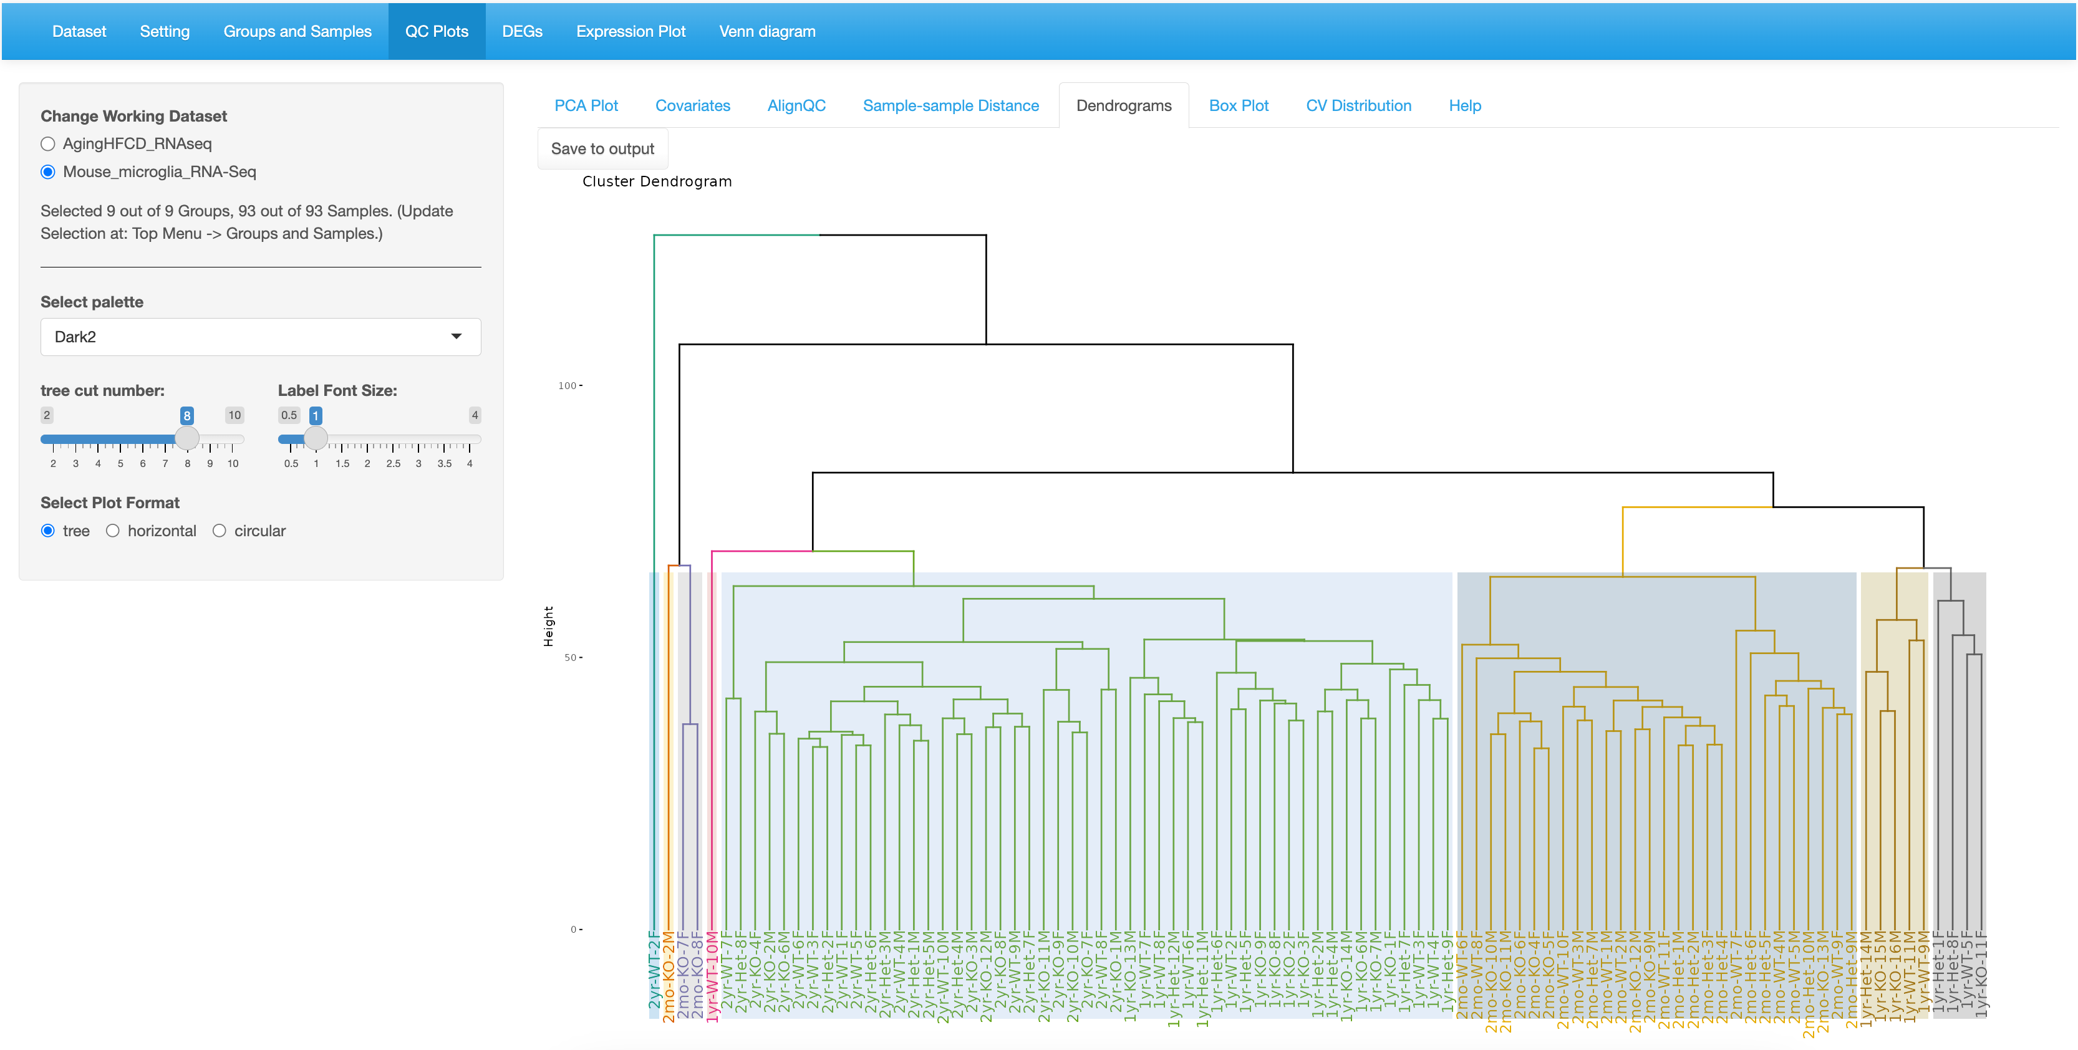

1.Cut into 8.

2. Select tree

2yr samples cluster together.